

Course PHYSICS 1
LABORATORY REPORT

Experiment Title: Determining resistances using a Wheatstone bridge (P3.2.3.4)

Name of the student: Elnur Gadirli

Group number: PAM 22.1
Team Number: 06

Experiment carried out: 8 December 2023
Lab report submitted: 8 December 2023

Supervisor: Associate Prof. G. Najafov

Synopsis
The primary objective of this report is to provide a comprehensive illustration of the resistance measurement process on a Wheatstone bridge, as conducted by Group - 06. The experiment involves the utilization of a Wheatstone bridge to determine resistances, and the subsequent discussion will delve into the outcomes generated from the experimental procedures. Furthermore, this report entails the application of various calculations employing formulas sourced from the laboratory leaflets.
The overarching aim is to offer a detailed exposition of the entire experimental procedure, shedding light on the intricacies of the process undertaken by our group. Additionally, a thorough examination of any challenges or issues encountered during the course of the experiment will be addressed. By elucidating both the procedural aspects and potential hurdles faced, this report strives to provide a comprehensive and insightful account of the conducted resistance measurement experiment.
Introduction
The objective of our laboratory experiment revolves around gauging the resistance of Rx by comparing it with a precisely known resistance, denoted as R. Essentially, we employ the accurately established value of R as a reference to ascertain whether the resistance of Rx aligns with that of R. Our methodology hinges on determining if the results obtained through this comparison correspond to the values derived from solving the relevant equations. In essence, the experiment aims to validate the accuracy and reliability of our resistance measurements by ensuring that the resistance of Rx is indeed in concordance with the precisely known resistance, R, through a systematic and equation-based approach.
Theory
During the course of the experiment, we utilized a variable but well-known resistance system alongside another resistance denoted as R. Employing the null balance method, we can accurately determine the precise resistance of Rx. Subsequently, our analysis involves a comparison of the obtained results by applying the equations provided below. This systematic approach enables us to assess and scrutinize the outcomes, ensuring a meticulous examination of the resistance values and their correlation as part of our comprehensive investigation.
(1) $Rx=\frac{s1}{s2}*R$
The determination of resistance, achieved through the null balance, remains unaffected by the applied current and is equally feasible with non-stabilized power supplies. To enhance accuracy in our measurements, it is optimal to ensure equality between the lengths of the wire sections, s1 and s2, by bifurcating the wire at its midpoint. This strategic adjustment facilitates a more precise comparison and evaluation of values during the resistance measurement process. Therefore, the alignment of the lengths of both sections, s1 and s2, becomes a pivotal factor in optimizing the accuracy of our experimental outcomes. So,
(2) $Rx=R$
In this setup, the pilot wire is divided into two sections, namely s1 and s2, by a sliding contact. Through the introduction of Rx and R into the circuit, monitored by an ammeter functioning as a null indicator, we aim for a current alignment of 0. In accordance with Equation 2, the determination of the unknown resistance becomes straightforward. This involves initially positioning the sliding contact at the midpoint and then adjusting the variable resistance until the ammeter registers zero. This specific configuration enables a direct equivalence between the value of the variable resistance, denoted as R, and the value of Rx, thereby providing a direct and precise means of identifying the unknown resistance in the circuit.
Experimental techniques
Apparatus
- 1 Demonstration bridge, 1 m long.........................536 02
- 1 Measuring resistor 10 Ω, 4 W............................536 121
- 1 Measuring resistor 100 Ω, 4 W..........................536 131
- 1 Measuring resistor 1 kΩ, 4 W............................536 141
- 1 Resistance decade 0 ... 1 kΩ.............................536 776
- 1 Resistance decade 0 ... 100 Ω..........................536 777
- 1 Resistance decade 0 ... 10 Ω............................536 778
- 1 Resistance decade 0 ... 1 Ω..............................536 779
- 1 DC power supply 0...+/- 15 V.............................521 45
- 1 Galvanometer C.A 403......................................531 13
- 3 Connecting leads, 50 cm, black.........................501 28
- 1 Pair of cables, 1 m, red/blue..............................501 46

Setup and carrying out the experiment:
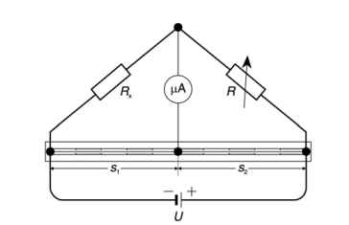

Initiate the experimental setup by precisely determining the lengths of the wire sections, s1 and s2. Proceed to calibrate the resistance decades, ensuring that R is set to Rx/2. Subsequently, power up the DC supply, fixing the voltage at 1 V. In a systematic fashion, manipulate the resistance values of R to 10, 100, and 1000 ohms for distinct testing scenarios. 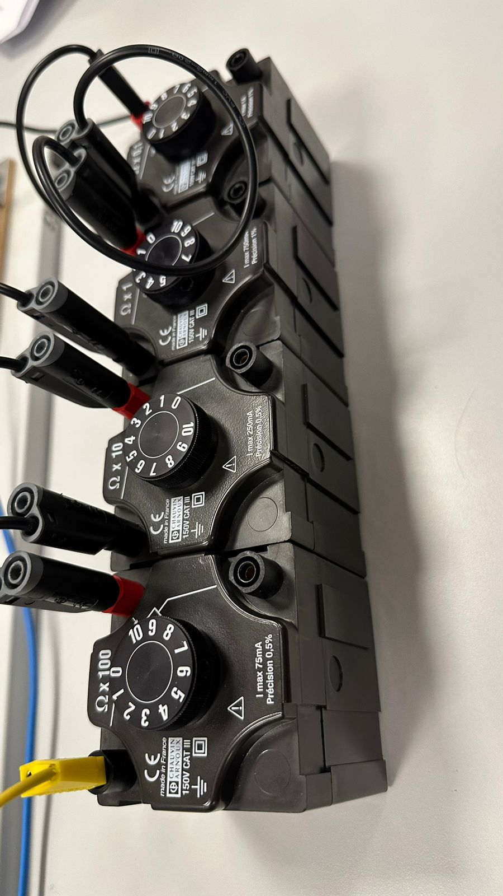
Figure 1

Following these configurations, carefully observe the ammeter to confirm its alignment at I=0, in correspondence with the predetermined lengths of s1 and s2. This zero-current condition serves as a crucial indicator during the experiment. Conclude the setup phase by applying the established rules to deduce the resistance value of Rx under the specified conditions.
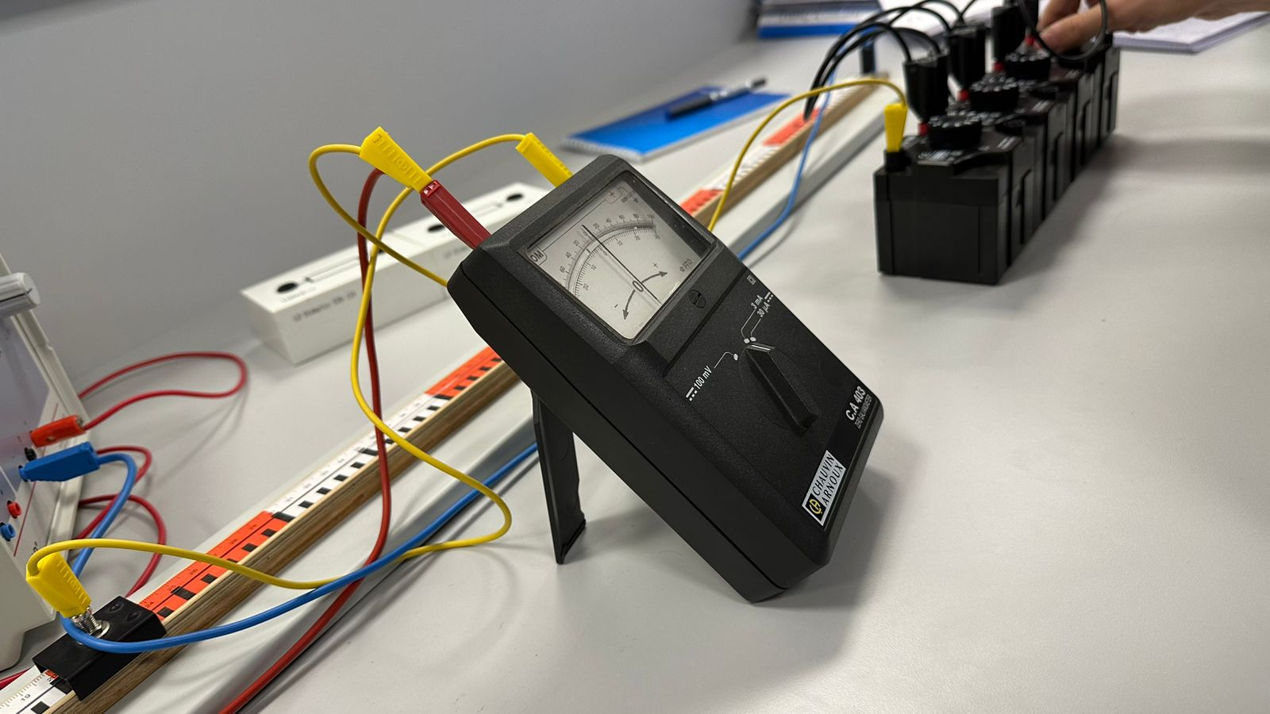
Figure 2
For a comprehensive analysis, replicate the experiment across a spectrum of R values and varying lengths. This iterative approach ensures a thorough exploration of the resistance configurations, contributing to a robust understanding of the experimental outcomes and facilitating a meticulous assessment of the resistance measurement process.
Achieve a null balance by making adjustments to the resistance decades.
Ensure uniformity in wire lengths by splitting the wire at the midpoint, allocating 50 cm to both sections, denoted as s1 and s2. Affix the measuring resistor, calibrated at 10 Ω, and establish a reasonable configuration for the resistance decades. Adjust the power supply to a voltage of 1 V.
Harmonize the resistance decades to achieve a null balance, signified by the ammeter registering I = 0 A within the smallest measuring range. Document the resulting values of Rx and R in a systematic table. Replicate the experiment, varying the measuring resistors to expand the scope of the analysis and derive a comprehensive set of observations.
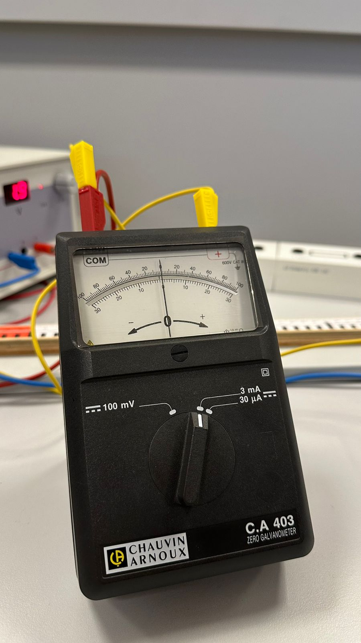
Figure 5
Results-Experimental and derived:
Following the provided instructions, we executed the experiment, yielding results that are essential for determining the resistance of Rx.
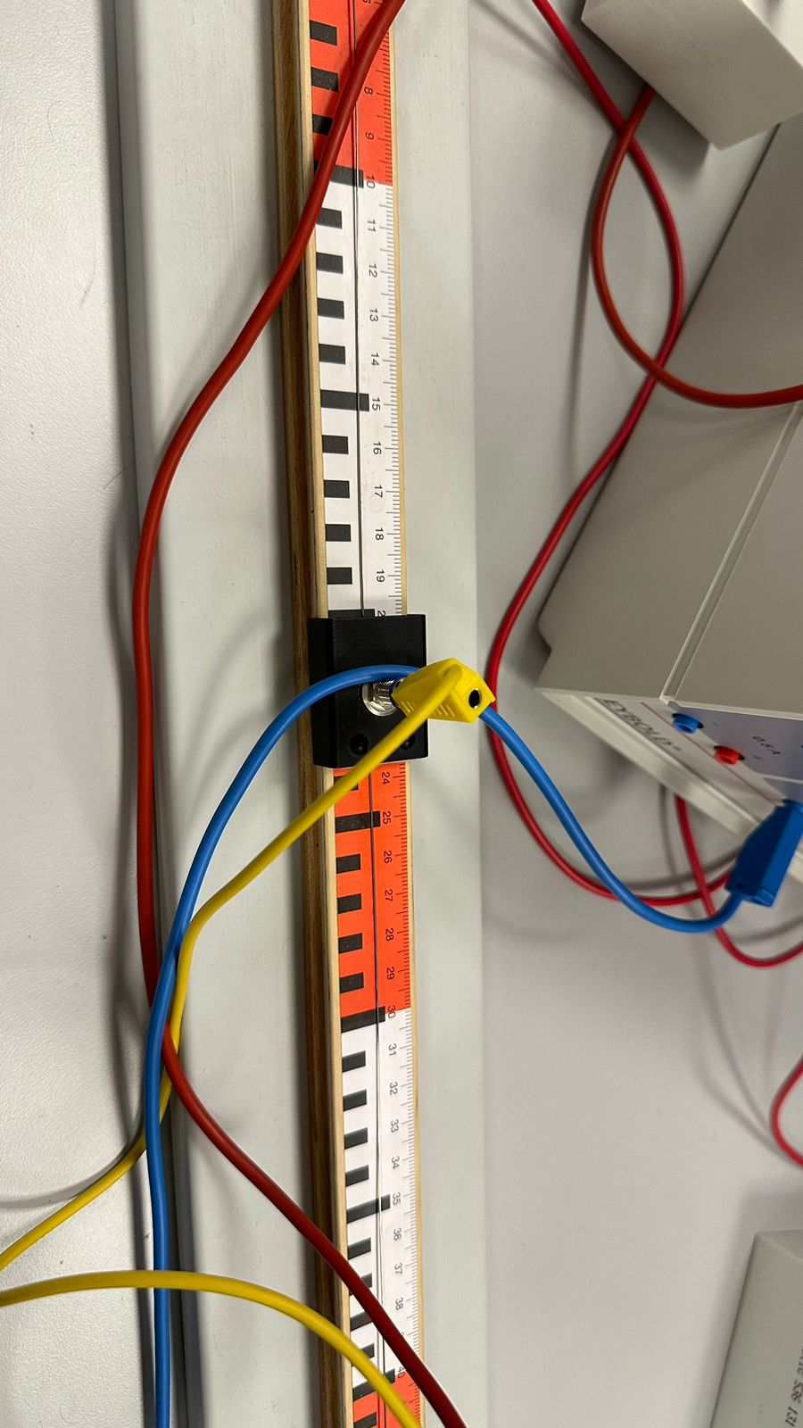
Figure 4

Results defined from the experiment:
R (Ω) | S1 (cm) | S2 (cm) | Rx (Ω)
10 | 50 | 50 | 12
 | 80 | 20 | 42
 | 20 | 80 | 3.2
100 | 50 | 50 | 115
 | 80 | 20 | 411
 | 20 | 80 | 27
1000 | 50 | 50 | 1111
 | 20 | 80 | 281
 | 40 | 60 | 721

Results derived from the equations.
R (Ω) | S1 (cm) | S2 (cm) | Rx (Ω)
10 | 50 | 50 | 10
 | 80 | 20 | 40
 | 20 | 80 | 2.5
100 | 50 | 50 | 100
 | 80 | 20 | 400
 | 20 | 80 | 25
1000 | 50 | 50 | 1000
 | 20 | 80 | 250
 | 40 | 60 | 666.67

Discussion of results
Looking at the tables in detail, we notice that the equations were proven for each situation, and we correctly found the implicit Rx. In each phase, we changed the length s1 and s2 and R as well to see and determine the Rx in each situation in null balance. However, it is quite noticeable that there are some errors between the values that are derived from the experiment and those from equations. But the values that are derived from calculations and experiment are in agreement. These small errors can be related to temperature issues, connection problems and wire resistance. Overall, our experiment was accomplished.
Conclusion
Despite encountering a few challenges, our experiment successfully met its objectives. We meticulously recorded the required quantities in the provided table, notwithstanding some minor errors. Our methodology included precise analysis and systematic organization of the data, contributing to the experiment's success. We considered both quantitative and qualitative aspects to comprehensively understand the outcomes. In summary, our experiment, though not without its errors, proved to be successful.
.References
Laboratory leaflets, BHOS laboratory.

